Website Project Proposals 1[Document subtitle]
Joseph Monnamoholo Moreki
[Company name] [Company address]
Contents
1. Organisation Overview 1
2. Website Goals and Objectives 1
3. Current Website Analysis 2
4. Proposed Website Features and Functionality 2
5. Design and User Experience 3
6. Technical Requirements 3
7. Timeline and Milestones 4
8. Budget 4
9. References 5

PROPOSAL 1: Karabo Nail Bar and Hair Salon — Small Business Website

1. Organisation Overview
Name: Karabo Nail Bar and Hair Salon
Brief History:
Karabo Nail Bar and Hair Salon are a small, locally owned beauty business established to provide premium hair and nail care services to the community. The salon was founded with a passion for beauty, self-care, and empowering clients to feel confident. The name "Karabo," meaning "answer" in Sesotho, reflects the salon's mission to be the answer to all beauty needs.
Mission Statement:
To deliver exceptional, personalised hair and nail services in a welcoming, professional environment that celebrates every client's unique beauty.
Vision Statement:
To become the most trusted and sought-after nail bar and hair salon in the local community, known for quality, creativity, and outstanding customer care.
Target Audience:
- Women and men aged 18–55
- Beauty-conscious individuals seeking professional nail and hair services
- Local community members and walk-in clients
- Clients seeking appointment-based luxury salon experiences

2. Website Goals and Objectives
Goals:
- Increase online visibility and attract new clients
- Enable online appointment booking to reduce phone call volumes
- Showcase services, pricing, and salon portfolio
- Build brand credibility and trust with potential clients
Key Performance Indicators (KPIs):
- Monthly website traffic (target: 500+ unique visitors per month within 3 months)
- Online appointment bookings (target: 30+ bookings per month)
- Bounce rate below 50%
- Social media click-through rate from website links
- Customer enquiry form submissions
According to Chaffey and Ellis-Chadwick (2022), setting measurable KPIs is essential for evaluating the effectiveness of a digital presence and ensuring organisational objectives are met.

3. Current Website Analysis
Karabo Nail Bar and Hair Salon currently have no existing website. The business relies on word-of-mouth and social media platforms such as Instagram and Facebook for marketing. While social media provides engagement, it lacks the professional credibility and functionality that a dedicated website offers.
Weaknesses Identified:
- No central online presence for booking or information
- Limited discoverability via search engines (SEO)
- No dedicated platform for showcasing services and pricing
Areas for Improvement:
- Develop a professional website with SEO optimisation
- Integrate an online booking system
- Create a consistent brand identity online

4. Proposed Website Features and Functionality
- Homepage: Eye-catching hero banner with salon images, tagline, and call-to-action button ("Book Now")
- About Us Page: Salon history, mission, vision, and team profiles
- Services Page: Detailed descriptions of hair and nail services with pricing
- Gallery Page: Before-and-after photos of hair and nail work
- Booking Page: Integrated online appointment scheduling (e.g., Calendly or Books)
- Contact Page: Contact form, Google Maps embed, phone number, email, and social media links
- Testimonials Section: Client reviews to build trust
Beaird, George and Walker (2020) emphasise that clear navigation and well-structured content pages are fundamental to improving user experience and reducing bounce rates.

5. Design and User Experience
Colour Scheme:
- Rose gold (#B76E79), Soft Black (#1C1C1C), and Cream White (#FAF9F6)
- These colours reflect elegance, luxury, and femininity, appropriate for a beauty salon brand
Typography:
- Headings: Playfair Display (elegant serif font)
- Body Text: Lato (clean, readable sans-serif)
Layout and Design:
- Clean, modern layout with full-width imagery
- Mobile-responsive design to cater for clients browsing on smartphones
- Sticky navigation bar for easy access to all pages
User Experience Considerations:
- Simple, intuitive navigation with a maximum of 6 menu items
- Fast-loading pages with optimised images
- Accessibility considerations (sufficient colour contrast, alt text for images)
Low-fidelity wireframes will be developed using Figma to map out the homepage, services page, and booking page layouts prior to development (Interaction Design Foundation, 2023).

6. Technical Requirements
- Programming Languages: HTML5, CSS3, JavaScript
- Framework: Bootstrap 5 (for responsive design)
- Hosting: Afrihost or Hostinger (affordable South African-friendly hosting)
- Domain Name: www.karabonailbar.co.za
- CMS (Optional): WordPress with WooCommerce or a custom HTML/CSS site
- Booking Integration: Books API or Calendly embed

7. Timeline and Milestones
Milestone | Task | Target Date
Week 1–2 | Research, planning, and wireframes | February 2025
Week 3–4 | HTML structure and page creation | March 2025
Week 5–6 | CSS styling and responsive design | March 2025
Week 7 | JavaScript functionality and booking integration | April 2025
Week 8 | Testing, proofreading, and final submission | April 2025

8. Budget
Item | Estimated Cost
Domain Registration (. co.za) | R150/year
Web Hosting (shared hosting) | R1,200/year
Stock Images (free) | R0
Booking System (Books basic plan) | R0–R500/month
Website Development (student project) | R0
Total Estimated Annual Cost | R1,350–R7,350
Budget estimates are aligned with research from Hostinger (2024), which indicates that small business websites can be established at minimal cost using shared hosting solutions.

SITEMAP
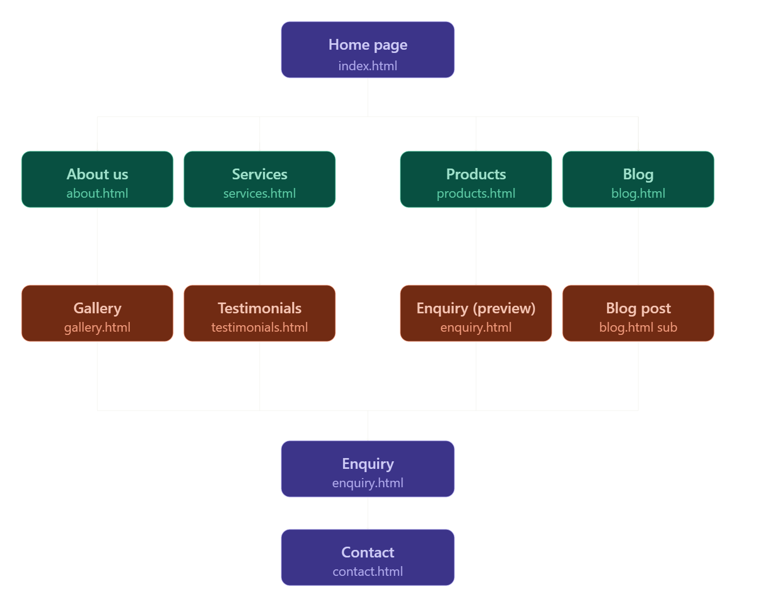

9. References
Beaird, J., George, J. and Walker, J. (2020) The Principles of Beautiful Web Design. 4th edn. SitePoint. Available at: https://www.sitepoint.com/premium/books/the-principles-of-beautiful-web-design-4th-edition/ (Accessed: 10 January 2025).
Chaffey, D. and Ellis-Chadwick, F. (2022) Digital Marketing: Strategy, Implementation and Practice. 8th edn. Harlow: Pearson Education.
Hostinger (2024) Web Hosting Plans and Pricing. Available at: https://www.hostinger.com/web-hosting (Accessed: 10 January 2025).
Interaction Design Foundation (2023) What is a Wireframe? Available at: https://www.interaction-design.org/literature/topics/wireframing (Accessed: 10 January 2025).

